- Sketch the titration curve for glycine.
(look at Figure 3-10 of Lehninger for reference).

  - Label the buffer zones present and at what pH they begin and end

  - Please note on your titration curve at what equivalent of base do the buffer zones begin and end. (feel free to use the Henderson-Hasselbach).

    - A and B should form a rectangle around each pK_{a} with precise values.

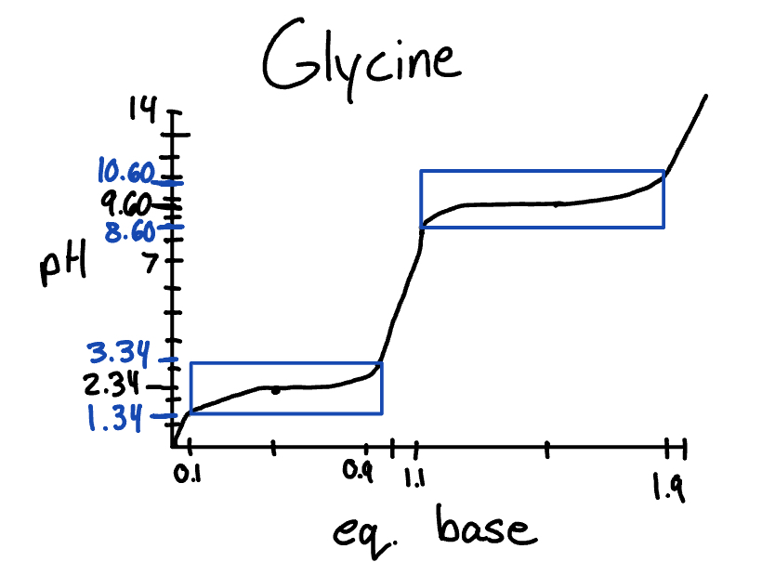

- If titrating 10.00 mL of 0.1 M amino acid, how many mL of 0.1 M NaOH is equal to 1 equivalent of base?

10mL is equal to one equivalent because the same number of moles will have been added.

- Sketch the titration curves for histidine, glutamate, and lysine. pH vs relative equivalence.

  - Label the buffer zones present in each amino acid and at what pH they begin and end

  - At what equivalent of base do the buffer zones begin and end?
(feel free to use the Henderson-Hasselbach).

    - Just like in question 1, A and B should form a rectangle around each pK_{a} with precise values.

  - Convert equivalents of base into mL of bases

  - eq = 1 mL
0.9 eq = 9 mL
1.1 eq = 11 mL
1.9 eq = 19 mL
2.1 eq = 21 mL
2.9 eq = 29 mL

